**Present and not present trigraphs**

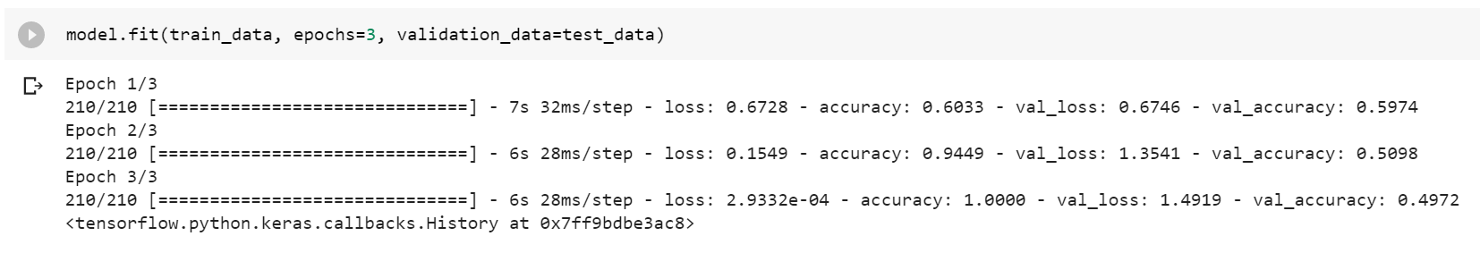

**Present and not present quadgraphs**

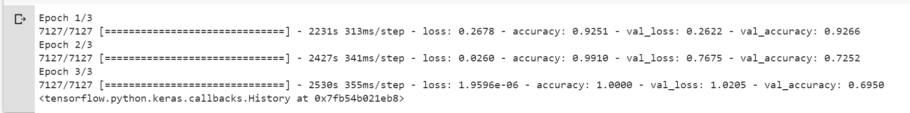

**Dictionary words with their digraphs and unprintables with non dict. digraphs**

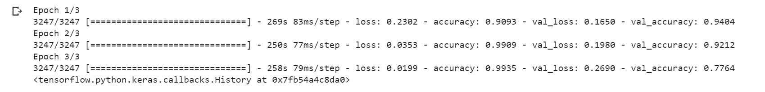

**Dictionary words with their trigraphs and unprintables with non dict. trigraphs**

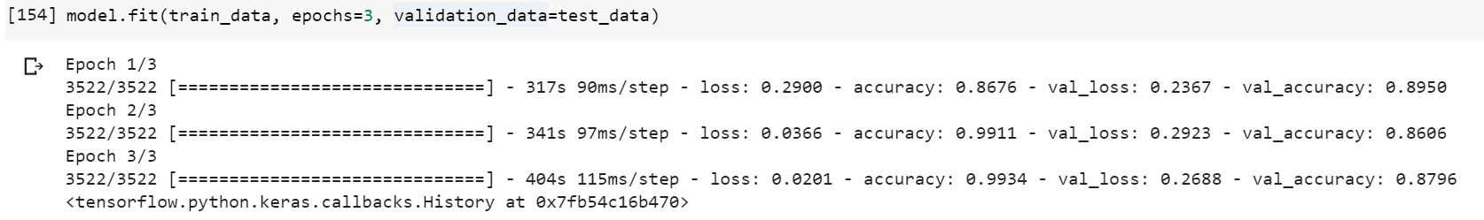

**Dictionary words with their quadgraphs and unprintables with non dict. quadgraphs**

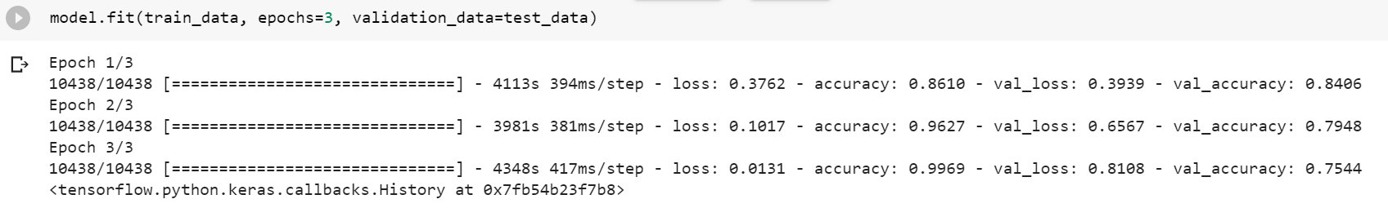

**Dictionary words and unprintables**

